**CURRICULUM VITAE**

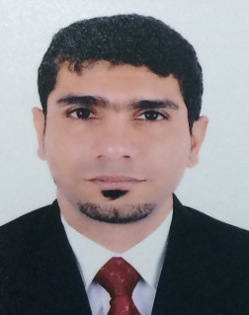**Name:** Ali Abd Ameer Ali Marhoon

**CPR Number:**  850406781

**Address:**  House No: 297, Road No. 4417

Block 644 Al Nuwaidrat

**Date of Birth:** 30 April 1985

**Mobile No:**  33337559 – 33115438

**E-mail:**  aliameer94@gmail.com

**Place of Birth:** Al – Malkeya

**Nationality:**  Bahraini

**QUALIFICATIONS**

|  |  |  |  |
| --- | --- | --- | --- |
| **Received** | **Institute / School** | **From** | **To** |
| Secondary School | Awal School | 1999 | 2001 |

**EXPERIENCE**

|  |  |  |  |
| --- | --- | --- | --- |
| Position | Company | From | To |
| * Security Guard | Shield Security Safety Services S.P.C | 04/01/2011 | 28/02/2013 |
| * Security Guard | Jawad Business Group | 20/07/2009 | 04/06/2010 |
| * Driver | Panorama Contracting & Engineering Services | 25/02/2005 | 19/04/2008 |
| My responsibilities & Training: Transportation the company material and labour from accommodation to all construction sites. | | | |
| * Labour with Machine Operator | Zeera United Factories Co. W.L.L | 25/01/2003 | 10/01/2005 |
| My responsibilities: Loading & handling the company material and machine operator. | | | |

**SKILLS**

* Good skill in Smart phone I can install the software in Apple phone and Galaxy, fix any problem inside the devise.
* Good using computer system (Microsoft Office, Word, Excel, Access, Power Point, ect).
* I have knowledge to solve computer problem like install the software, removing the virus, ect…
* I organize the activities in my village, addition to that I have a good experience in public relations and communication.
* I play football & basketball in my village Al Nuwaidrat Club.

**INTEREST**

Reading, internet, picnics, sports, swimming, playing football & basketball

**REFERENCES**

**Name Position Company Contact Number**

Mr. Hussain Alhaddar Engineer BBD 39266276-36002990

Ms. Fatima A.ameer Isa Ebrahim Bureau 39088044-36860446

of Attorneys